How do you choose a future career? | Some people know what they want to do in the future and others are still exploring many options.  Either way, the goal is to identify your interests and possible next steps to your future.
- Log into Naviance | 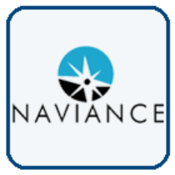  Username: district ID#  Password: district password
- Click Self-Discovery > Career Interest Profiler to identify suggested careers based on your interests and personality traits. | 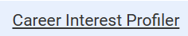  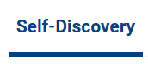
- Check out your Career Interest Profiler results. Your interests are mapped to six categories of personalities called the Holland Code. | 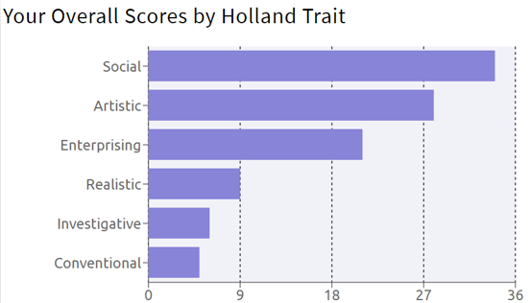
- Explore your results and get more information by clicking View Careers | 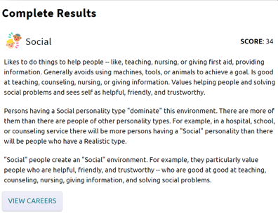  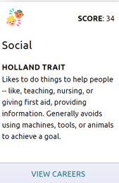
- Identify two careers AND two career clusters and pathways to favorite by clicking the heart icon. | 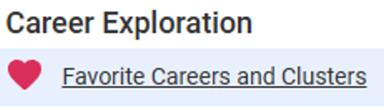  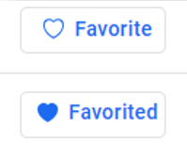
- Task Completion: | Complete the Career Interest Profiler and favorite two careers AND two clusters and pathways.

